MASS CALCULATIONS
Pearson Edexcel - Thursday 8 November 2012 - Paper 2 (Calculator) Higher Tier
1.
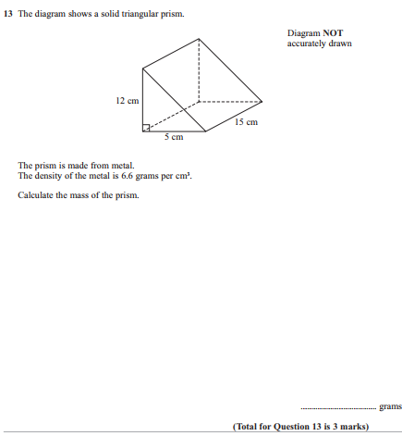

Pearson Edexcel - Wednesday 9 November 2011 - Paper 3 (Non-Calculator) Higher Tier
2.
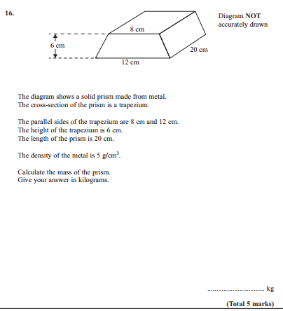

Pearson Edexcel - Monday 6 June 2011 - Paper 3 (Non-Calculator) Higher Tier
3.
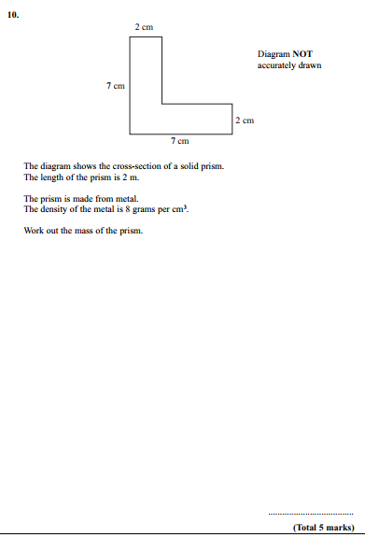

Pearson Edexcel - Friday 11 June 2010 - Paper 4 (Calculator) Higher Tier
4.
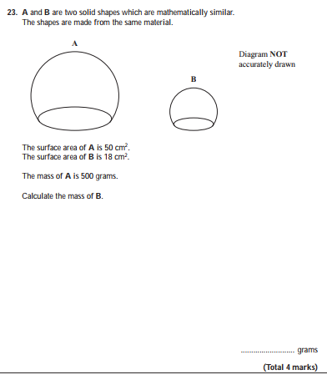
AQA GSCE – Tuesday 12 June 2018 – Paper 3 (Calculator) Higher Tier
5.
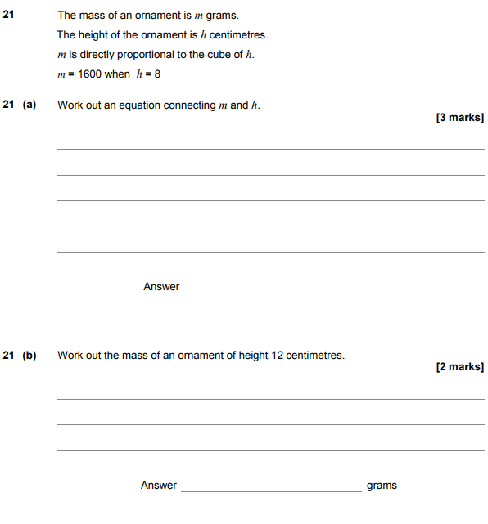

AQA GSCE – Tuesday 13 June 2017 – Paper 3 (Calculator) Higher Tier
6.
